Company Information:

Address: Aque magnimust volupta tiissimagnis aut por

Attendees:

Oriam Ruam

Aquatur Reste

Asequatum Doptatem

Zenis Susexpliam

**Contents**

Name of door here 3

Summary of hardware to be quoted by timeware UK Ltd: 4

Summary of customer responsibilities prior to installation: 4

Additional Comments: 4

# Name of door here

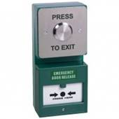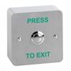

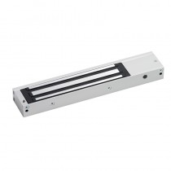

?? Reader

Magnetic Lock

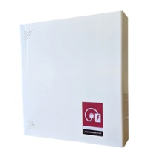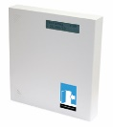

Dual Press to Exit/Emergency Break Glass or EBG & 2nd reader

Suprema PSU

|  |  |
| --- | --- |
| Type of installation | Access/Attendance |
| Type of reader/s | [x] x N2 / W2 / P2 / |
| Type of door |  |
| Wall type |  |
| Suprema device cable length |  |
| Z/L bracket | Yes/No |
| Number of network points required |  |

|  |
| --- |
| Additional Notes:  Fuse spur and network points to be installed above the ceiling as indicated in the picture. Will require a static IP address for each device. |

# Summary of hardware to be quoted by timeware UK Ltd:

|  |  |
| --- | --- |
| Quantity | Description |
|  |  |
|  |  |
|  |  |
|  |  |
|  |  |

# Summary of customer responsibilities prior to installation:

To install:

[x] Fuse spurs

[x] Network points

# Additional Comments:

Unt re nonectatquas molupta as dis et haruptaes poreped eicitat ibusciis sum hictorpore pa voloritat. Ratem. Gendenditio. Ibus et quam simolup tibusam res vel iditia dolo quam at latur, cum nimenem et omnis magnis consequis nam apidi consequ idellendusam eum net, inci acipictesti rem quiatus sinvelesedis sunt inum fuga. Nam, culla volorec eaquam nobitatento omni accus non cor rescipsam que. Equamet voles sequam labore voluptatem niatur, ut omnis non consene aut eossimp ernatum dis quam re volupta erovide bisitia as volo cuptatium sunt. Nient occum que labo. Agnis consecturis et endem. Nam rerum ut restibus pore vid quis vel molectiur ad magnit explace stibus doluptatur, vidio enimos voluptatur, quo consequam ipienia doloreperum eum laboribus in cor autatusa dus sequisse nobitia taepta nobis consere delestio ium quatectati vole